Meet your new Community Manager!
Community Association Manager

Jessica Griffin
240-651-3056
jgriffin@clagett.com

HOA Board of Directors
Craig Longcor, President
Colin O’Dell, Vice President
If you’re interested in joining the Board, please email jgriffin@Clagett.com

Website
www.NorthCrossing.org

Pool Passes

Pool Passes will be processed in the Spring. More details about registration will be sent out closer to April.

ARC Information

Changing something on the exterior of your home? Before you begin, approval is needed!
Please submit all ARC applications with supporting documents to Clagett Management:

jgriffin@clagett.com
or mail
5295 Westview Drive, Suite 125
Frederick, MD 21703
F: 301-695-9557

.

Jessica Griffin, CMCA took over as North Crossing’s Community Association Manager this past December. Jessica has several years of experience managing communities of similar size and style to North Crossing and is excited to assist the Board and Homeowners with all HOA matters. If you have any questions or concerns, please email jgriffin@clagett.com

***IMPORTANT CHANGE TO SNOW REMOVAL***
The Board had the snow contractor shovel all the sidewalks over the most recent snow events. Unfortunately, it is not sustainable to keep offering this service, the snow budget for 2024 has already been exceeded! To avoid another large increase in dues for 2025, the Board is changing the snow contract to only clear common areas and the one private road in the community (Beaver Pond Alley), EFFECTIVE IMMEDIATELY. Please note, Homeowner’s are responsible for the clearing of sidewalks adjacent to your property as part of your governing documents, see the Declaration, Article 5, Section 2.
Reminder, the streets are plowed by the City of Frederick. Make sure you are ready for any future snow/ice event!

Resident Contact Information
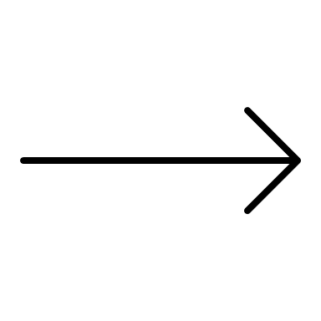
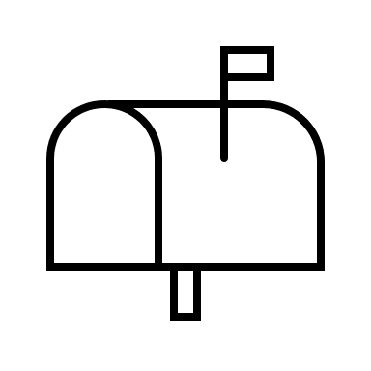
To save money, North Crossing would like to send out all Association correspondence via email! Please contact the association manager at jgriffin@clagett.com or 240-651-3056 to ensure your email is added to your unit file. If no email is on-file, you will receive information by “snail mail” otherwise known as USPS! If you are unsure if you have an email on file, please contact Clagett at 301-695-6676 and we can add any contact information you would like!

Yard Waste

Please do not place any yard waste, clippings, or debris behind your fence or property line. Many sections of North Crossing are being mistreated with discarded items and yard waste.

Please dispose of it properly by visiting:

Reichs Ford Road Yard Waste Recycling
9031 Reichs Ford Road, Frederick.
Hours: Monday-Saturday 7:00 am-4:30 pm
All pets need to be licensed and LEASHED at all times, and owners MUST pick up after their animal(s).

Pet Waste

Client Portal
Did you know you can check your HOA account balance and see any open compliance concerns on your account? Visit https://clagett.vmsclientonline.com and use your account number. A temporary password can be sent to you if you don’t have one.

Important Numbers
Street Light Out – Frederick City 301-600-1440
Frederick City Police
301-600-2100
(Non emergency)

Frederick City Code Enforcement 301-600-3832

Copy of Lease?
If you rent your home, please e-mail an executed copy of the lease to Jessica as it is HOA policy to supply one to management.

Next Meeting Date:
TBA
5295 Westview Dr, Ste 125
Frederick, MD 21703

*Dates are subject to change; please contact Jessica to confirm before you come

Friendly Reminders…

Trash

There have been multiple reports of rodents throughout the community, so to keep them off your property and out of the community, everyone needs to be more diligent in handling their trash.
Per the City of Frederick Trash Collection & Recycling Guidelines please follow these rules when placing trash out in the North Crossing Community.
- ALL waste needs to be BAGGED.
- ALL placement NEEDS to be at your designated PARKING SPOT NOT in COMMON AREA.
- Residents may use a 35 gallon or less cans, however bagged trash is acceptable. NO LOOSE ITEMS such as pizza boxes etc.
- Please set your trash out after 5PM on Monday evening and before Midnight the evening before collection.
These guidelines will be enforced by both North Crossing HOA and Clagett Management. If these guidelines are NOT followed initial violation notices will be processed. Repeat violations will be assessed fines.
Bulk items must NOT be placed in the common areas under any circumstances. If you have large items that need to be disposed of, the City of Frederick offers free pick up once a year, and you may register online at: www.cityoffrederickmd.gov/237/Bulk-Trash-Collection
If these guidelines are NOT followed initial violation notices will be processed. Repeat violations will be assessed fines.

Bulk Pick-up

